# JS Advanced: Exam Preparation

Problems for exam preparation for the [“JavaScript Advanced” course @ SoftUni](https://softuni.bg/courses/javascript-advanced). Submit your solutions in the SoftUni judge system at <https://judge.softuni.bg/Contests/353/>.

## Delete Town by Name (Simple DOM Interaction)

You are given the following **HTML code**:

|  |
| --- |
| delete-town-by-name.html |
| <!DOCTYPE **html**> <**html**> <**head**>  <**title**>Delete Town by Name</**title**>  <**style**>**select**, **input** { **width**: 100**px** }</**style**>  <**script src="https://code.jquery.com/jquery-3.1.1.min.js"**></**script**> </**head**> <**body onload="***attachEvents*()**"**> <**div**>Towns</**div**> <**select id="towns" size="4"**>  <**option**>Sofia</**option**>  <**option**>Varna</**option**>  <**option**>Pleven</**option**> </**select**> <**div**>  <**input type="text" id="townName"** />  <**button id="btnDelete"**>Delete</**button**> </**div**> <**div id="result"**></**div**> <**script**>  **function** *attachEvents*() {  *//* ***TODO***  } </**script**> </**body**> </**html**> |

### Your Task

**Write the** **missing JavaScript code** to make the **[Delete]** button work as expected.

* The **[Delete]** button should **delete all towns** from the list **matching** the value in the “townName” text box.
* After a town is successfully deleted, show a message *“<town_name> deleted.*” in the “result” div.
* When the town is missing, show a message “*<town_name> not found.*” in the “result” div.
* In all cases clear the value in the “townName” text box.

### Examples

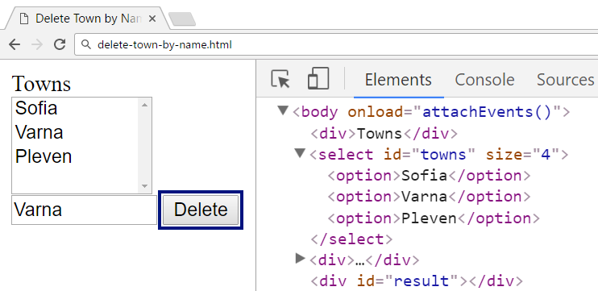

↓

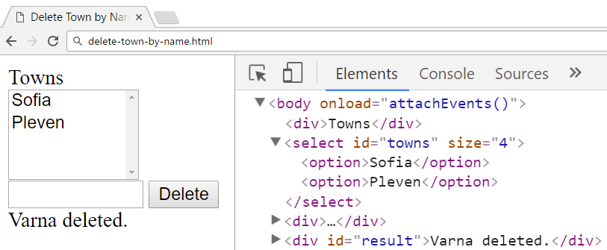

↓

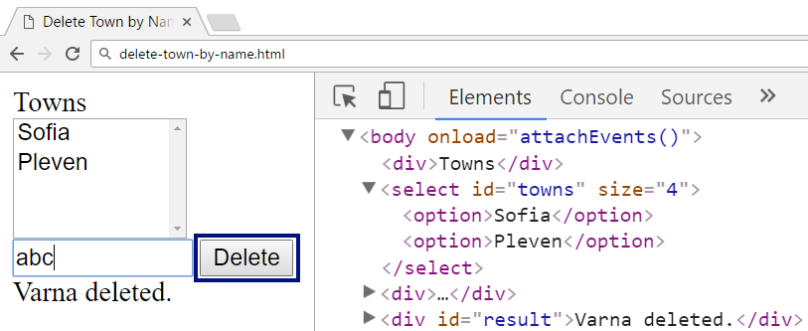

↓

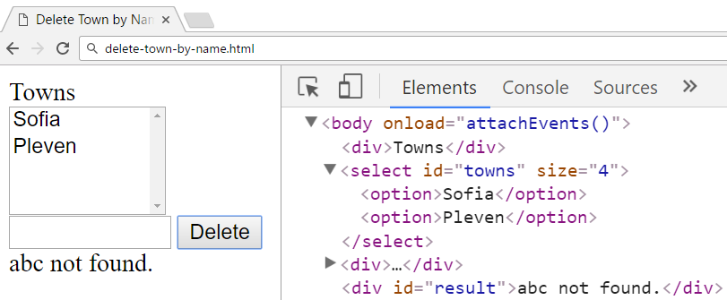

### Submission

Submit your attachEvents function as “**JavaScript code (DOM unit tests)**”.